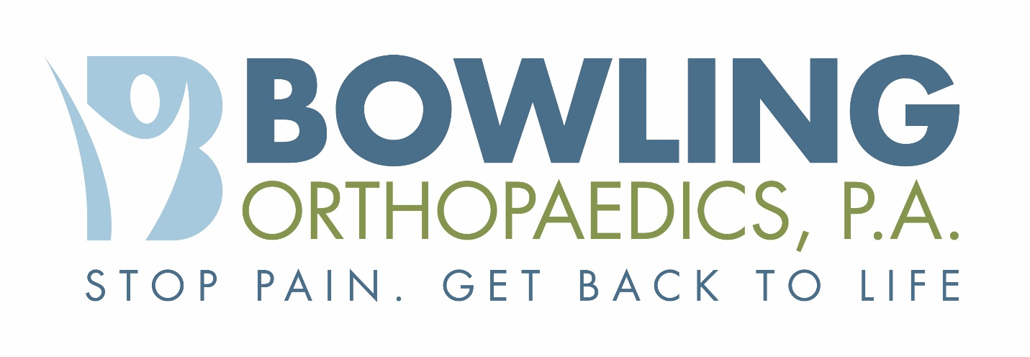

Authorization for Release of Health Information
As required by the Health Insurance Portability and Accountability Act of 1996, Bowling Orthopaedics, P.A. may not use or disclose your health information except as provided in our Notice of Privacy Practices without your authorization. Your signature on this form indicates that you are giving permission for the use and disclosure of protected health information described herein.

Patient’s Name: ____________________________________ Date of Birth: __________________ Age: _______

Street Address: ____________________________________ City/State/Zip: _________________________________

Primary Phone: ____________________________________ Social Sec #: _________________________________

Purpose of Release: [ ] Ongoing Communication [ ] Copy of Record [ ] Legal or Insurance Review [ ] Authorized Representative’s Request

[ ] Other:_______________________________________________________________________________________________________

Release From: The entity listed below is authorized to release the requested health information:

[ ] Bowling Orthopaedics, P.A. 5220 Oleander Drive 2nd Floor, Wilmington, NC 28403 Phone : (910) 395-8333 Fax: (910) 395-8473

[ ] Other:_______________________________________________________________________________________________________

The entity listed above is authorized to release the requested health information for the following date(s) of services, range of tie or event(s):

[ ] All dates of service OR From: (MM/DD/YY)________________________ To: (MM/DD/YY)_____________________________

Information to be released: [ ] Office Notes [ ] Operative Reports [ ] Diagnostics / Xrays [ ] Lab results [ ] Other:____________

Release To: This information may be released to the following entity:

[ ] Self

[ ] Other:_______________________________________________________________________________________________________

PATIENT AUTHORIZATION: I understand that the information in my medical record may include information relating to treatment of drug or alcohol abuse, sickle cell anemia, psychological or psychiatric impairments, sexually transmitted disease, acquired immunodeficiency syndrome (AIDS), AIDS related complex (ARC) and/or human immunodeficiency virus (HIV).

I understand that I am giving authorization for the release of certain private medical information to the above noted party. I understand that once the health information I have authorized to be disclosed reaches the noted recipient, that person or organization may re-disclose it, at which time it may no longer be protected under the Privacy Laws. I understand that I may revoke this authorization at any time.

Print Name of Patient/Authorized Representative:________________________________________________________Date:______________

Patient / Authorized Representative Signature:___________________________________________________________Date:______________

If the patient is a minor or is clinically unable to sign, an authorized representative may sign this authorization.
If Authorized Representative, please indicate relationship to patient:[ ] Spouse [ ] Parent [ ] Guardian [ ] Executor of Estate [ ] Power of Attorney

PLEASE NOTE: THIS AUTHORIZATION WILL EXPIRE ONE YEAR FROM ORIGINAL DATE SIGNED.

Bowling Orthopaedics, P.A.
Jack W. Bowling Jr., M.D. • Ryan Murphy P.A.-C. James R. Bennett P.A.- C
5220 Oleander Drive 2nd Floor, Wilmington NC, 28403
Phone: (910) 395-8333 • Fax: (910) 395-8473

